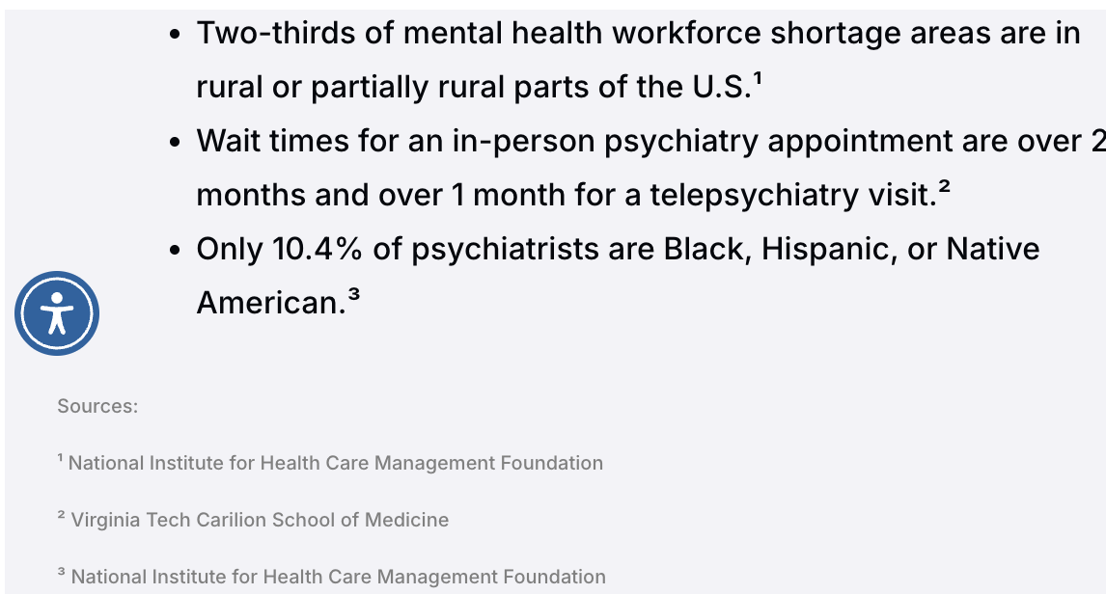
Who needs Chronilogix?
This cannot be solved with humans
Its not about human or AI… its having continuity of care… an aopointment last 50 minutes. The time between appointments can be a month. A lot can happen to influence someone during that time without any type of motivational contact, not just did you take your meds contact
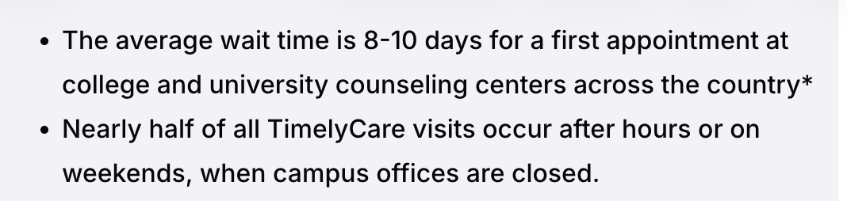

AI Overview
Mental illness costs the U.S. economy annually, an aggregate burden equivalent to an average economic recession and roughly
of the country's total annual consumption.
Columbia Business School +1
This figure includes the following breakdowns of cost:
- Lost Productivity: The largest driver of this cost is indirect, manifesting as lower workforce participation and significantly reduced workplace output.
- Direct Healthcare Spending: Direct spending on mental health and substance use disorders (SUD) exceeds per year.
- Inequity-Related Costs: Some estimates suggest that avoidable expenses and health inequities associated with mental health cost the economy an additional annually.
CNBC +2
How much money is spent on mental health in the US?
AI Overview
The U.S. spends over $280 billion annually on mental health and substance use disorders. When broken down into individual healthcare costs, the average American spends roughly $1,080 per year out-of-pocket and through insurance on mental health treatments, which equates to about 5% of the average monthly income.
Tebra +1
The financial picture is broken down into direct medical spending and broader economic impacts:
- Direct Medical Spending: The United States spends over $139 billion specifically on mental health and substance use disorder treatments.
- Broader Economic Burden: Broader estimates—which include lost workforce productivity and indirect economic impacts of undertreated mental health—push the total cost to more than
$282 billion each year.
- Individual Treatment Costs: For those without insurance, an hour-long traditional therapy session ranges from to
Nearly 1 in 10 Americans has taken on debt to pay for these treatments.
- State-by-State Discrepancies: State mental health agency spending varies widely. Hawaii leads the nation with average expenditures of $$$14,779 per client annually, compared to much lower rates in states like Florida ($$$3,083) and Kentucky ($$$1,641).
Health Affairs +5

The newest evidence on AI coaches for emotional wellbeing and diabetes is increasingly showing measurable clinical benefit — especially when the systems are structured around evidence-based behavioral coaching rather than generic chatbot conversation. The strongest results are emerging in three areas:
- Reduction in depression/anxiety symptoms
- Improved engagement and adherence
- Better diabetes outcomes through behavioral change

Emotional Wellbeing: Latest Results

Voice-Based AI Therapy Comparable to Human Coaching
A 2025–2026 Phase 2 randomized trial of the AI voice coach “Lumen” tested AI-delivered problem-solving therapy against both human therapists and a waitlist control. Participants had clinically significant anxiety and depression.
Key findings after 18 weeks:
- Psychological distress improved significantly versus control
- Improvement score difference: -3.56 points on standardized anxiety/depression measures
- AI coaching outcomes were not significantly different from human-coached therapy
- Improvements in problem-solving ability mediated mental health gains (MedRxiv)
This is important because it suggests structured AI coaching can reproduce portions of evidence-based psychotherapy at scale.

Depression Reduction Data
Multiple recent AI mental health studies are reporting:
- 31% reduction in anxiety symptoms
- 51% reduction in depression symptoms in some early AI-therapy cohorts (Reddit)
Naturalistic real-world studies of generative AI mental health systems also showed:
- Significant reductions in PHQ-9 depression scores
- Significant reductions in GAD-7 anxiety scores
- Improvements in:
  - hope
  - social support
  - loneliness
  - behavioral activation
  - perceived connection
- Benefits sustained up to 10 weeks in follow-up (arXiv)

Engagement and Therapeutic Alliance
One of the biggest surprises in recent research is how strongly users bond with AI coaches.
Studies reported:
- High engagement rates
- “Working alliance” scores approaching traditional therapy benchmarks
- Higher disclosure rates due to:
  - reduced stigma
  - 24/7 access
  - perceived non-judgmental interaction (arXiv)
This matters because behavioral outcomes in therapy are heavily correlated with consistency and engagement.

Personalized/Empathetic AI Performs Better
A randomized study using GPT-4 with “supportive listener” instructions found:
- Greater reductions in anxiety/depression scores compared with standard GPT interactions
- Higher empathy ratings
- Better language-style matching correlated with improved outcomes (arXiv)
This reinforces the idea that AI coaching architecture and conversational design matter enormously.

Diabetes: Latest Results

Cleveland Clinic AI Diabetes Coaching Study
One of the strongest recent diabetes studies came from a Cleveland Clinic-led program using AI-supported precision health coaching.
Results:
- 71% of participants achieved HbA1c ≤ 6.5%
- Participants used fewer diabetes medications
- Personalized AI recommendations improved glycemic control significantly (Cleveland Clinic)
That level of diabetes control is clinically meaningful and economically valuable.

AI-Guided Treatment Optimization
Another 2025 study using interpretable AI treatment guidance found:
- HbA1c reductions improved by:
  - 0.26% better than physician-only treatment in one cohort
  - 0.13% better in external validation cohorts (arXiv)
Even a 0.5% A1c reduction is considered meaningful in diabetes care, so incremental improvements at population scale are highly significant financially and medically.

Where AI Coaches Appear Strongest
The evidence is strongest when AI is used for:
- behavioral coaching
- motivational interviewing
- CBT/PST-style interventions
- adherence support
- habit reinforcement
- journaling and reflection
- lifestyle coaching
- emotional regulation
The evidence is weaker when AI tries to replace:
- complex psychotherapy
- crisis intervention
- severe psychiatric management
- human relational attachment

Emerging Commercial Advantages
Healthcare systems and payers are interested because AI coaching can potentially deliver:
- 24/7 support
- near-zero marginal scaling cost
- multilingual support
- culturally adaptive coaching
- longitudinal engagement
- reduced clinician burden
- improved medication adherence
- reduced hospitalizations and complications
For diabetes and obesity programs specifically, AI coaches can:
- improve daily adherence
- increase weight-loss persistence
- reinforce nutrition behaviors
- reduce dropout rates
- maintain motivation between clinician visits
That is why AI coaching is becoming strategically attractive for:
- wellness platforms
- employer health programs
- payer care management
- obesity/GLP-1 programs
- chronic disease management companies

Important Risks and Limitations
The field is also seeing growing warnings about:
- emotional dependency on AI
- hallucinated advice
- reinforcement of distorted thinking
- inadequate crisis escalation
- lack of clinical oversight
- over-reliance replacing human connection (The Guardian)
The strongest consensus emerging is:
AI coaches work best as scalable behavioral support systems — not as full replacements for clinicians or human relationships.
That positioning is increasingly important for both regulators and enterprise healthcare buyers.

